**9/2/2022 Meeting Notes**

1. Gantt Chart – Has been updated, please read it over. This “should” be the final update. If you have any questions contact Amber.
2. Google Drive – Has been reorganized. Please get comfortable with the layout of it and where things are located.
3. Engineering Notebook – Has been added to the google drive. With the following layout:

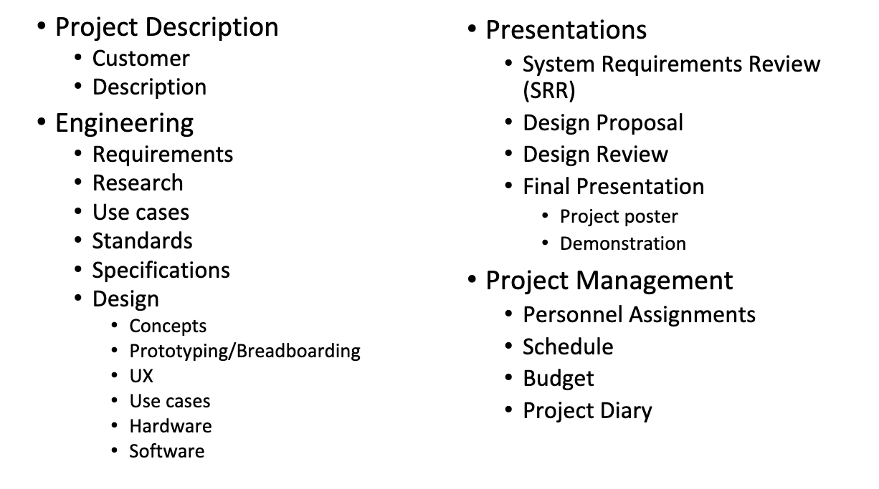

If everyone could help by adding something to some of the word documents in this folder that would be great!

1. Programming – We will be using C# with Unity for the application and Python to interface with the HoloLens
2. Code – Stefano is currently working on a tutorial on building a central Python server that multiple TCP clients, including HoloLens can connect to. He will continue to work through Part 2 and 3. To view his progress thus far look at the GitHub: <https://github.com/himmel99/AR-Annihilators/tree/PyTCPHololens>
3. Sponsor - We need to decide on a sponsor and contact them. Stefano recommends Dana Wortman which is a C# professor. If no one else has a suggestion by the next meeting we will be contacting Dana.

**Finish this week:**

<https://drive.google.com/drive/folders/13H7k91rOR-CoOCh8NsqFUjAyA57s6lcn?usp=sharing>

1. Message the group discord, look at other sections, or the examples on canvas (when Bill finally uploads them) for help.
2. Update hours log and Gantt chart.
3. Conceptual Design Report: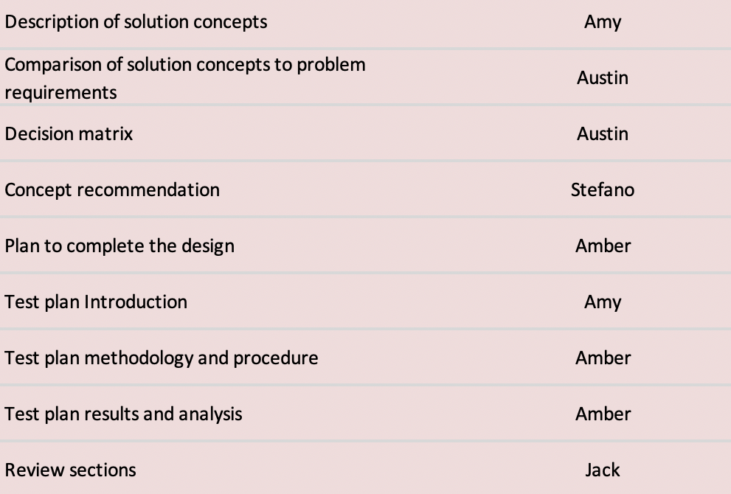

**Work due 9/16/22 - 9/17/22:**

1. Conceptual Design Presentation - Everyone
2. Actual Design:
   1. Develop Probability function – Jack
   2. Develop object detection algorithm/function – Austin, Amber
   3. Develop/design overlay and graphics – Stefano
   4. Develop/add audio effects – Amy
   5. Develop code to connect to HoloLens – Stefano, Austin